Activity 5: Blog Platform

Description: Blog posting platform. Users can register to post blog and comment. Unregistered users can only view blog posts.

System UI Screenshot
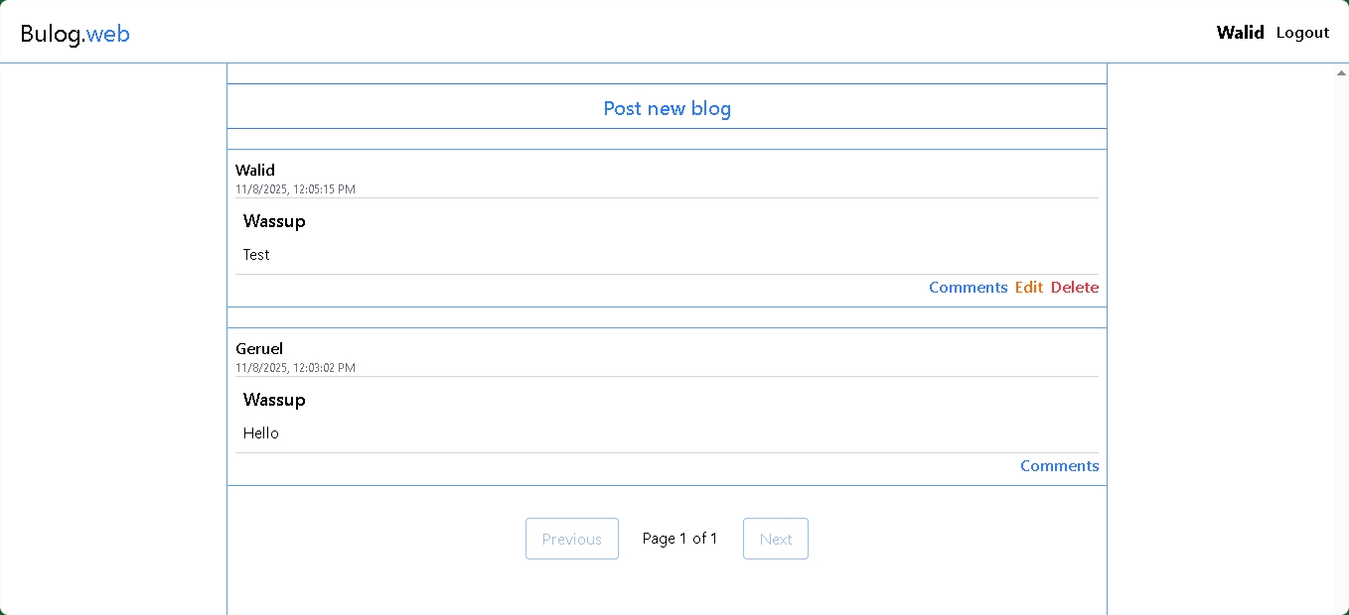

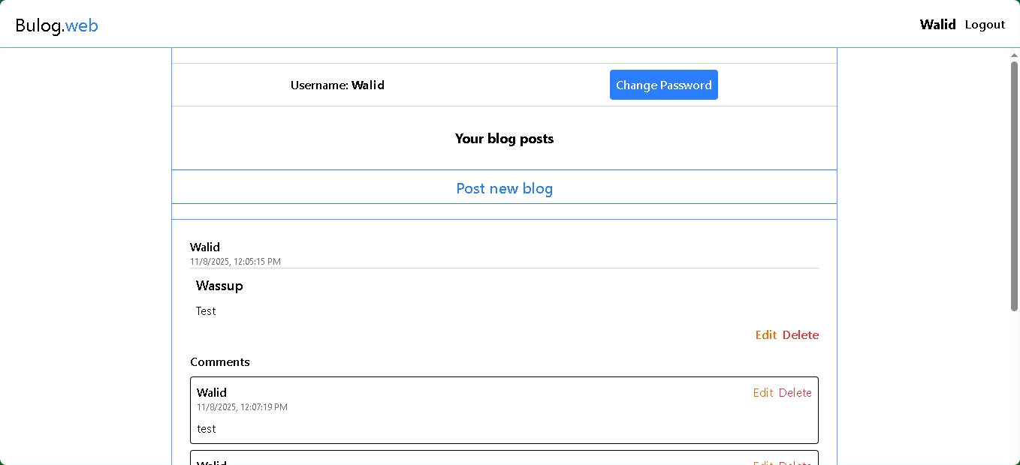

API Documentation Screenshot

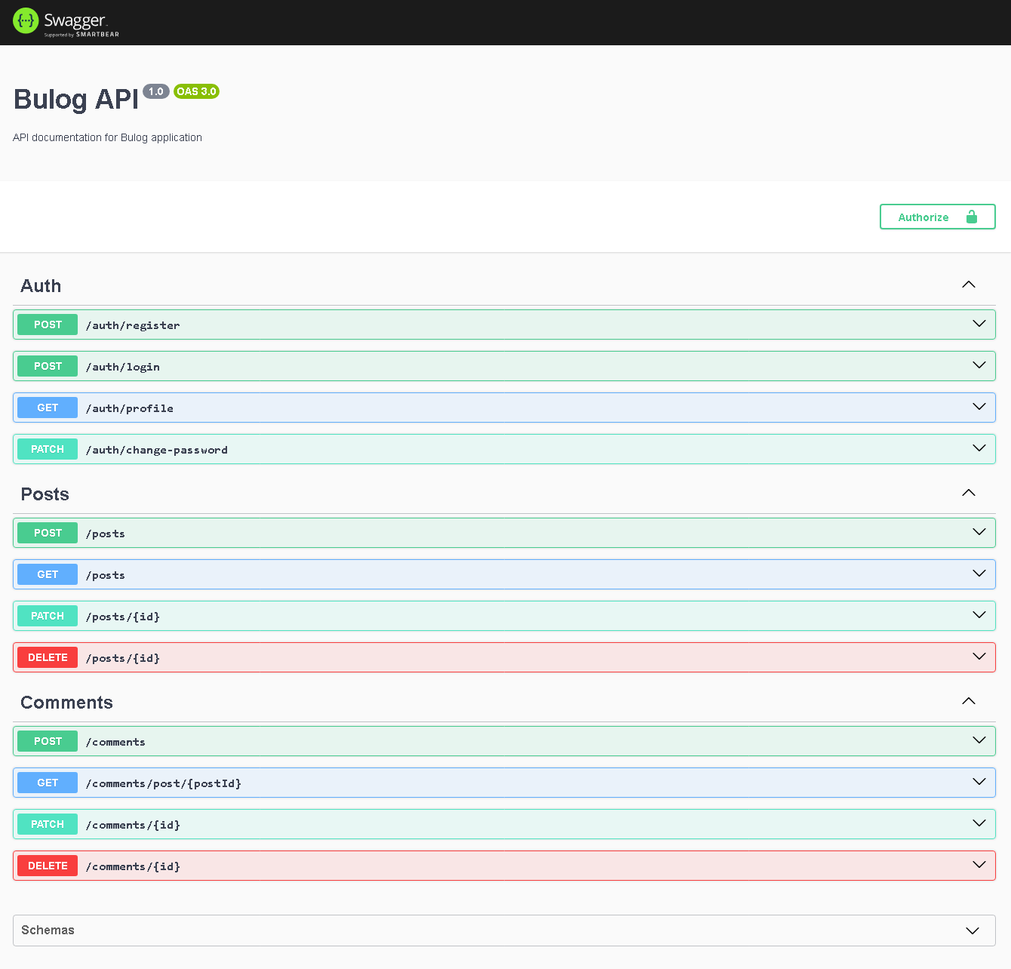

How to run the project:
- Start a terminal on systems folder
- Type “npm start” command and Enter

